LUCKNOW PUBLIC SCHOOL

(C. P. SINGH FOUNDATION)



Project Report

*Informatics Practices(065)*

(Session: 2023-24)

Student Name : Ashutosh Prajapati

Class : XII

Section : A

Roll No. :

CERTIFICATE

name : class/sec :  
roll no : Exam Name: Aissce

XII-A

ASHUTOSH PRAJAPATI

This is to certify that content of this project

***Bike Showroom Management***

by

***Ashutosh Prajapati***

is the bonafide work of him/her submitted to

***Lucknow Public School, Jankipuram***

for consideration in the partial accomplishment of the provision of CBSE,

for the award of

***All India Senior Secondary Certificate Examination***

in

***Informatics Practices -065***

the ORIGINAL RESEARCH work was carried out by him/her under my supervision in the academic year 2023-24. on the basis of the declaration made by him/her, I recommended the project report for evaluation.

examiner’s signature teacher in-charge

principal

date stamp

ACKNOWLEDGEMENT

I take this opportunity with great pleasure and respect to express my first and foremost thanks to the principal,

“**Mrs. Shabnam Singh”**

for her encouragement and for the facilities that she provided for this project work. I extend my hearty thanks to

**“Mr. Abhay Pratap Singh”**

Informatics Practices Teacher who guided me throughout the successful completion of this project. I take this opportunity to express my deep sense of gratitude for his guidance, constant encouragement, immense motivation, which has sustained my efforts at all the stages of thisproject.

I can’t forget to offer my sincere thanks to the parents and to also my classmates who helped me to carry out this project work successfully and for their valuable advice and support, which I received from time to time.

**CONTENT**

* INTRODUCTION
* SOFTWARE & HARDWARE REQUIREMENT
* SOURCE CODE IN PYTHON
* OUTPUT SCREEN
* SOFTWARE REVIEW FORM
* BIBLIOGRAPHY

**INTRODUCTION**

This project aims to create a user-friendly and simple **“BIKE SHOWROOM MANAGEMENT SYSTEM”**

in which it allows the user to purchase a vehicle and the system enters its record in the database along with the previously stored data and allows user to receive the bill for their respective purchases.

The system is created by using the following technologies:

* **Python** – A general purpose programming laguage which is popular around the world and is easy to learn and use.
* **Tkinter** – A built-in module in Python language which allows user to create Graphic User Interfaces (GUIs).
* **Pandas** – A Python library used for data management and manipulation
* **CSV(Comma Separated Values)** – A file format used to store data.

**SOFTWARE AND HARDWARE**

**REQUIREMENT**

**Software Specification: -**

**Operating system:** Windows 7 or above

**Platform:** Python IDLE 3.10 or above

**Languages:** Python

**Hardware specification: -**

**Processor:** Dual core or above

**Hard Disk:** 40 GB

**RAM:** 2 GB

**Note:**

Please install the following libraries before running the program:

* Pandas
* Tkinter (if not built-in)

**SOURCE CODE**

**TEXT:**

**# imports**

**import pandas as pd**

**from tkinter import \***

**import tkinter as tk**

**from datetime import datetime**

**# configuring tkinter window**

**win = Tk()**

**win.geometry('700x500')**

**win.title("Welcome to TVS AP MOTORS")**

**win.rowconfigure(index=15,weight=1)**

**win.columnconfigure(index=12,weight=1)**

**# form**

**customername = StringVar()**

**fathername = StringVar()**

**emailid = StringVar()**

**phone = StringVar()**

**model = StringVar()**

**price = IntVar()**

**qty = IntVar()**

**mddict = {"Jupiter110cc": 68998,"NTORQ125CC": 73490,"RR310": 78590,"XL100": 84990,"Raider125": 86990,"Ronin225": 265000}**

**mdlsavail = ['Jupiter110cc','NTORQ125CC','RR310','XL100','Raider125','Ronin225']**

**mdlsprice=[68998,73490,78590,84990,86990,265000]**

**Label(win,text="MODELS AVAILABLE WITH THEIR PRICE").grid(row=1,column=0)**

**for i in range(6):**

**Label(win,text=mdlsavail[i],borderwidth=1,relief='solid',width=26).grid(row=i+1,column=1,columnspan=1)**

**Label(win,text=mdlsprice[i],borderwidth=1,relief='solid',width=26).grid(row=i+1,column=2)**

**Label(win,text="Customer Name *").grid(row=7,column=0)**

**Label(win,text="Father Name * ").grid(row=8,column=0)**

**Label(win,text="Email ID * ").grid(row=9,column=0)**

**Label(win,text="Phone Number * ").grid(row=10,column=0)**

**Label(win,text="Model").grid(row=11,column=0)**

**Label(win,text="Quantity").grid(row=12,column=0)**

**Label(win, text='Entries with * are mandatory.').grid(row=13,column=0)**

**Entry(win , width=30,textvariable=customername).grid(row=7,column=1)**

**Entry(win , width=30,textvariable=fathername).grid(row=8,column=1)**

**Entry(win , width=30,textvariable=emailid).grid(row=9,column=1)**

**Entry(win , width=30,textvariable=phone).grid(row=10,column=1)**

**Entry(win , width=30,textvariable=model).grid(row=11,column=1)**

**Entry(win , width=30,textvariable=qty).grid(row=12,column=1)**

**# pandas**

**def datasend():**

**df = pd.read_csv('project\\bikepurchaseDB.csv')**

**if model.get() in mdlsavail and phone.get().isnumeric() == True:**

**entrydict={'Customer':customername.get(),'Father':fathername.get(),'Email':emailid.get(),'Phone':int(phone.get()),'Model':model.get(),'Price':mddict[model.get()],'Quantity':qty.get()}**

**df.loc[len(df.index)]=entrydict**

**else:**

**errorwin = Tk()**

**Label(errorwin,text='Enter valid Details.').pack()**

**Button(errorwin,text='OK',command=errorwin.destroy).pack()**

**errorwin.mainloop()**

**df.to_csv('school\\c12\\project\\project2.0\\bikepurchaseDB.csv', index=False)**

**print(df)**

**# new window**

**def new_window():**

**billwin = Toplevel(win)**

**billwin.columnconfigure(index=5,weight=1)**

**billwin.rowconfigure(index=7,weight=1)**

**billwin.title('BILL | AP MOTORS')**

**Label(billwin,text=' AP MOTORS', font=('Algerian',36)).grid(row=1,column=1,columnspan=3)**

**Label(billwin,text=' XYZ Road, Jankipuram, Lucknow - 226220', font='Arial').grid(row=2,column=1,columnspan=3)**

**Label(billwin,text=' Email - apmotorslko@hotmail.com Contact - 0522-696969', font='Arial').grid(row=3,column=1,columnspan=3)**

**Label(billwin,text='Details of Customer Date:{} Time:{} \n Name: {} s/o {} | Email: {}'.format(datetime.now().date(),datetime.now().strftime("%H:%M:%S"),customername.get(),fathername.get(),emailid.get()),font=('Arial',10),borderwidth=1,relief='solid',width=91).grid(row=4,column=1,columnspan=4)**

**Label(billwin,text='Description of Goods',font=('Arial',12),borderwidth=1,relief='solid',width=50).grid(row=5,column=1)**

**Label(billwin,text='Quantity',font=('Arial',12),borderwidth=1,relief='solid',width=10).grid(row=5,column=2)**

**Label(billwin,text='Rate',font=('Arial',12),borderwidth=1,relief='solid',width=10).grid(row=5,column=3)**

**Label(billwin,text='Amount',font=('Arial',12),borderwidth=1,relief='solid',width=10).grid(row=5,column=4)**

**Label(billwin,text='{} {}'.format('TVS',model.get()),font=('Arial',12),height=5,width=50,borderwidth=1,relief='solid',anchor=N).grid(row=6,column=1)**

**Label(billwin,text='{}'.format(qty.get()),font=('Arial',12),borderwidth=1,relief='solid',height=5,width=10,anchor=N).grid(row=6,column=2)**

**Label(billwin,text='{}'.format(mddict[model.get()]),font=('Arial',12),borderwidth=1,relief='solid',height=5,width=10,anchor=N).grid(row=6,column=3)**

**Label(billwin,text=(mddict[model.get()]*qty.get()),font=('Arial',12),borderwidth=1,relief='solid',height=5,width=10,anchor=N).grid(row=6,column=4)**

**Label(billwin,text='TOTAL AMOUNT',font=('Arial',12),borderwidth=1,relief='solid',height=2,width=71,anchor=CENTER).grid(row=7,column=1,columnspan=3)**

**Label(billwin,text=(mddict[model.get()]*qty.get()),font=('Arial',12),borderwidth=1,relief='solid',height=2,width=10,anchor=CENTER).grid(row=7,column=4)**

**Button(win , text='SUBMIT', command=datasend).grid(row=14,column=1)**

**Button(win , text='BILL', command=new_window).grid(row=14,column=2)**

**mainloop()**

**-------------------------------------------------------------------------------------------------------**

**IDLE:**

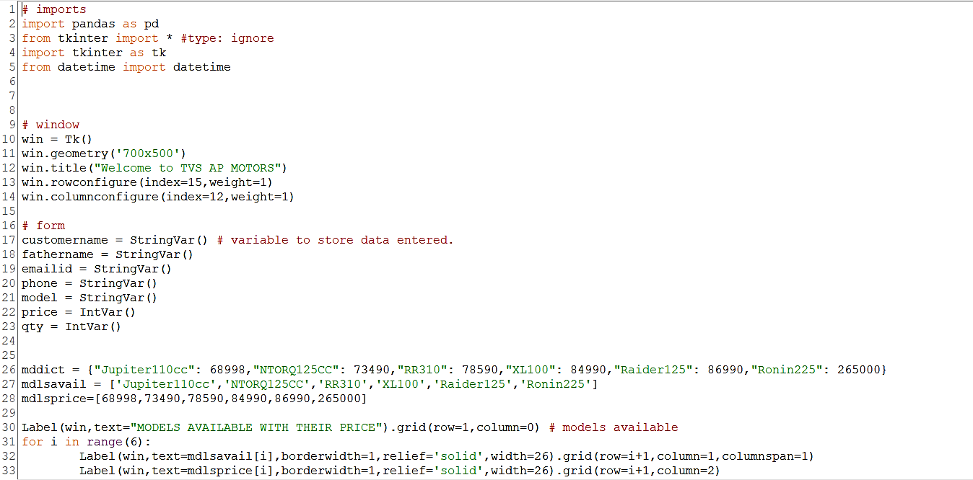

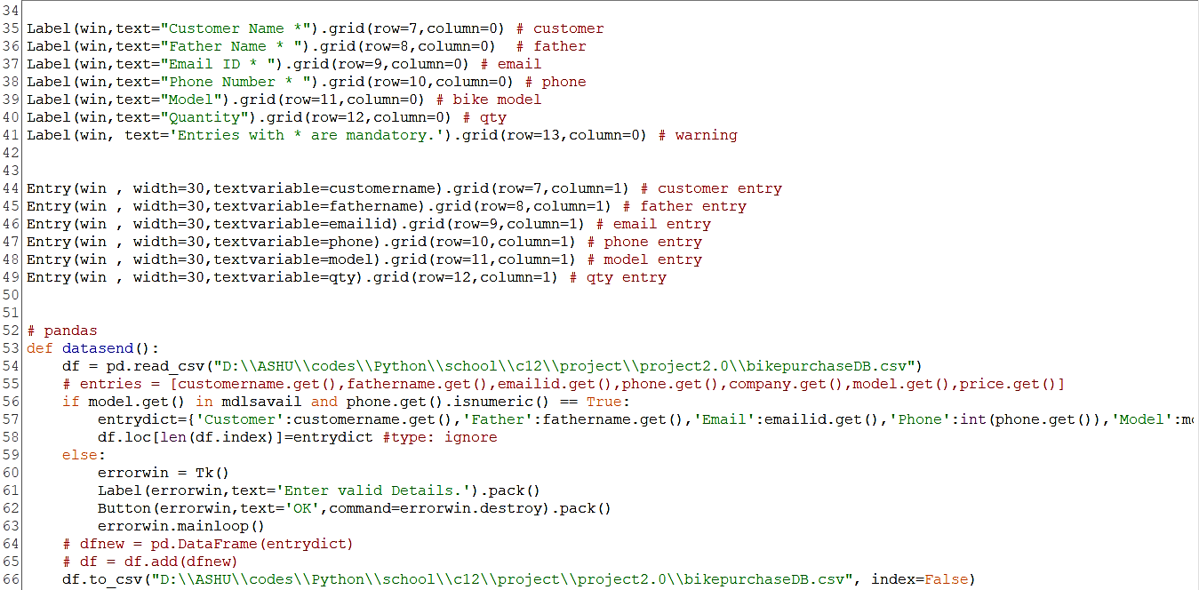

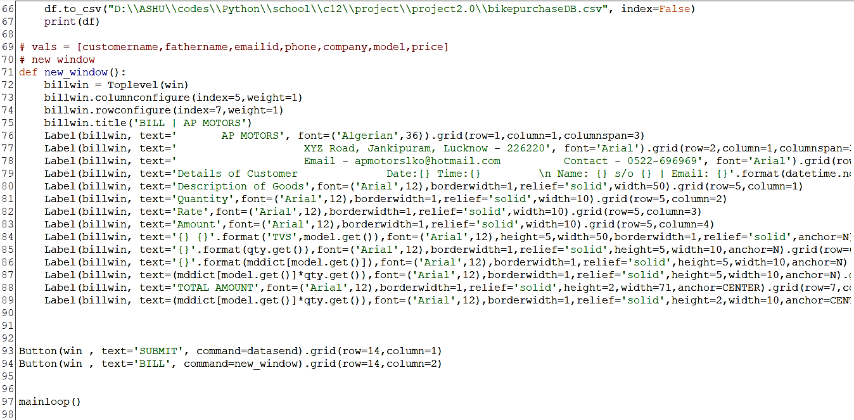

OUTPUT

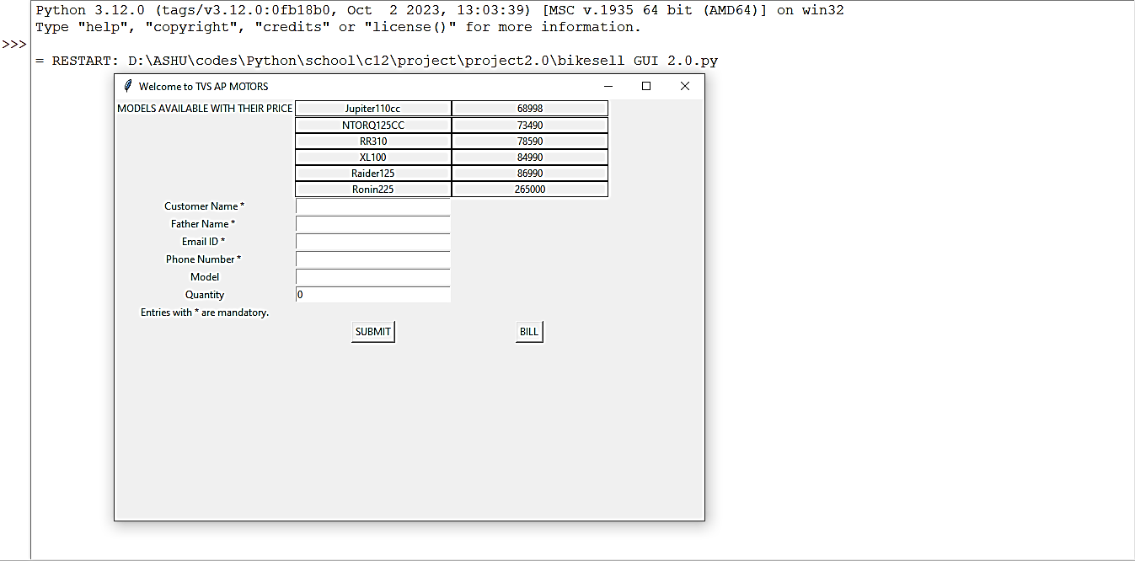

**Entry Form (by Tkinter)**

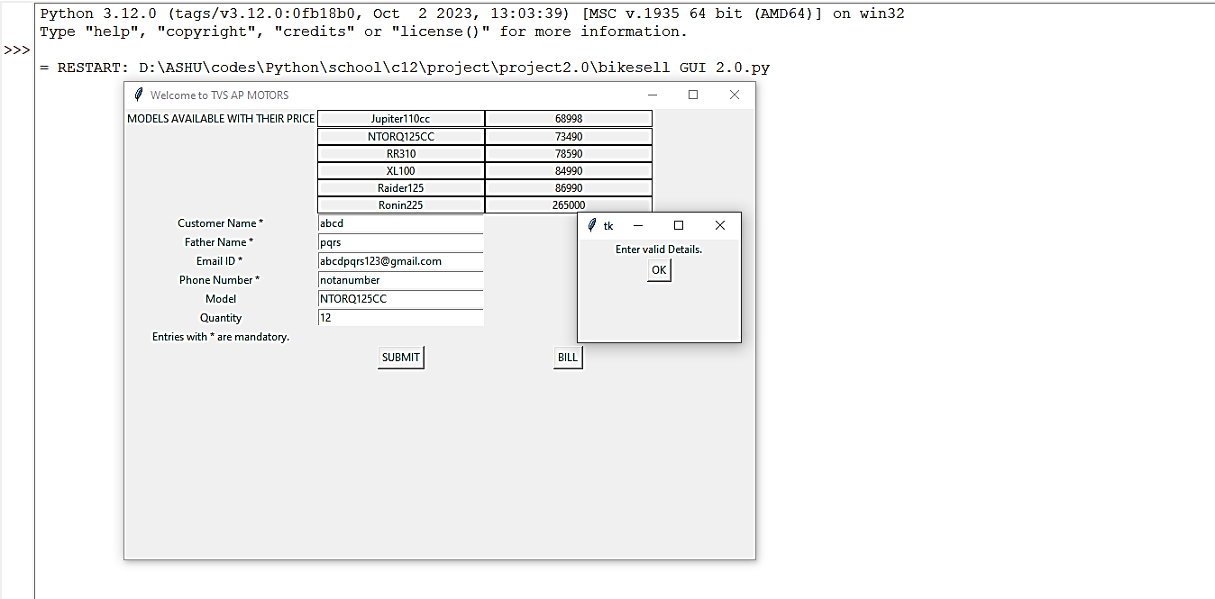

**Error Window**

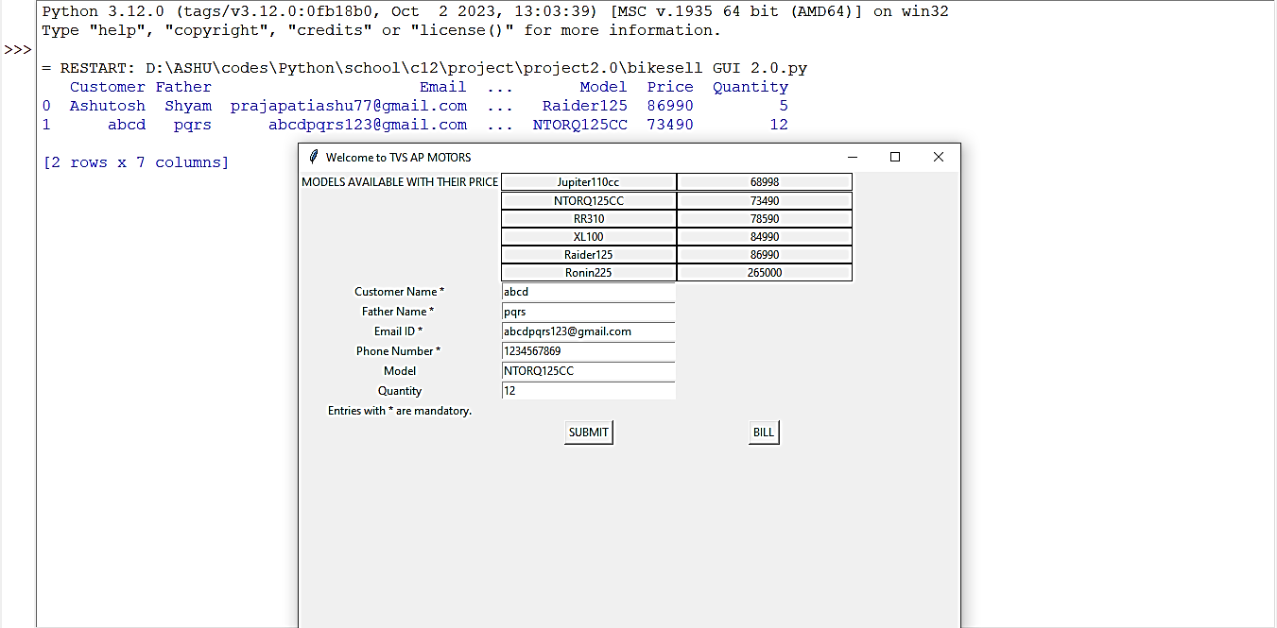

**Data stored in CSV file**

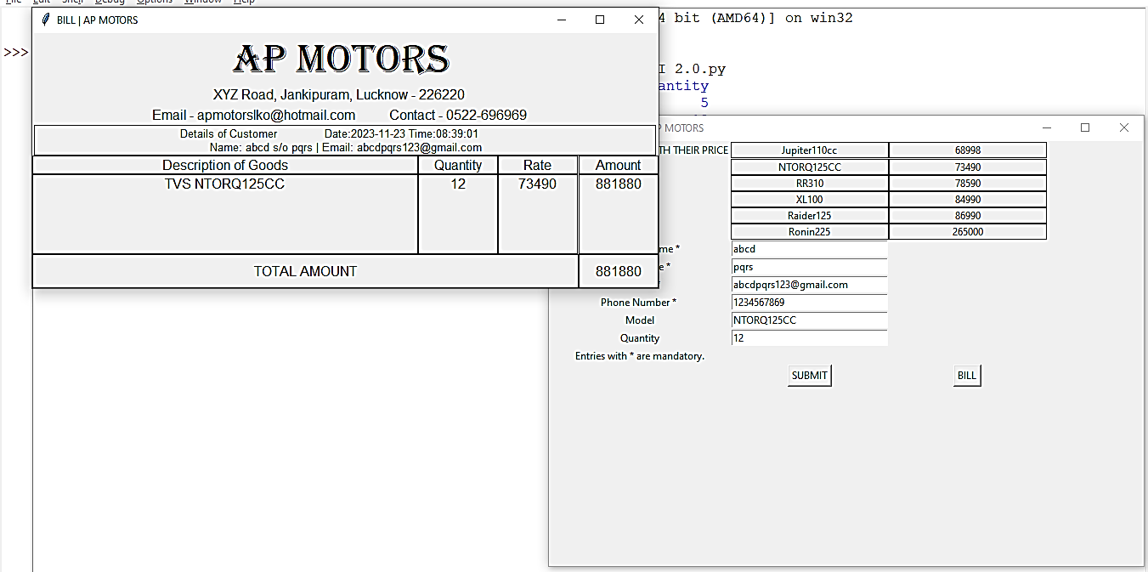

**Bill with Date & Time**

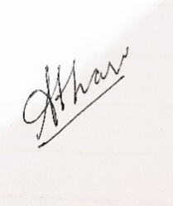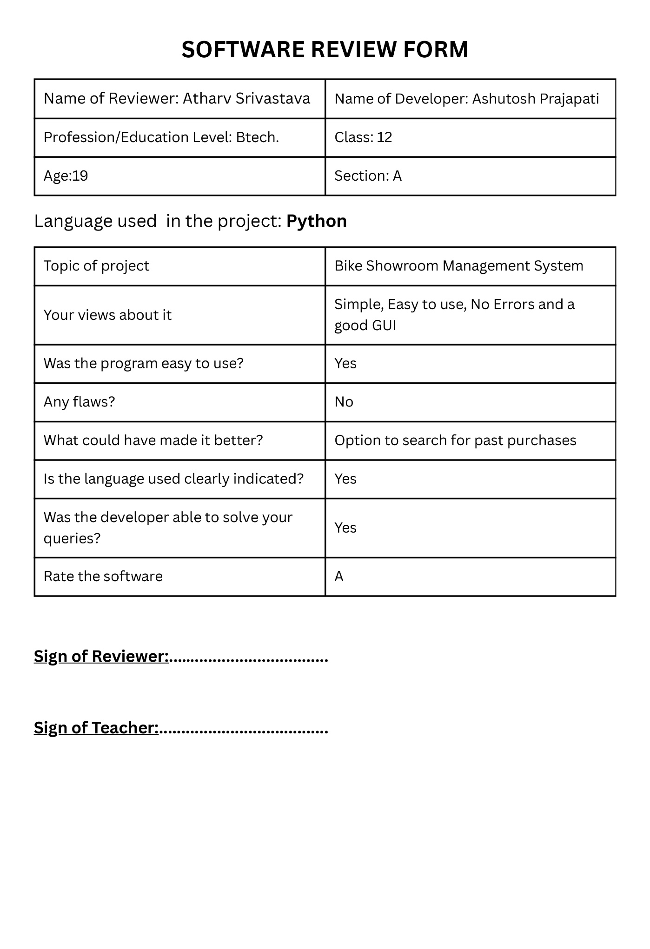

**BIBLIOGRAPHY**

* Informatics Practices (NCERT) Class 12
* Informatics Practices (Sumita Arora) Class 12
* <https://www.google.com/>
* <https://www.geeksforgeeks.org/python-gui-tkinter/>
* <https://www.geeksforgeeks.org/python-pandas-dataframe/>
* <https://www.geeksforgeeks.org/python-datetime-module/>
* <https://www.w3schools.in/python/gui-programming>